History of commands to be executed:

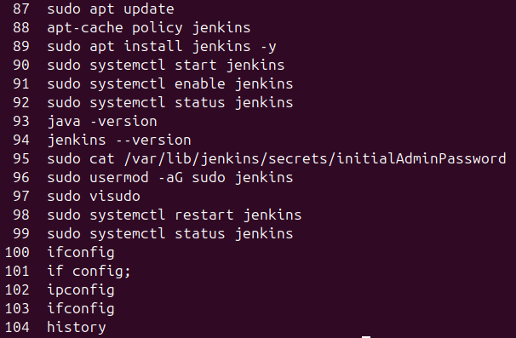

In the jenkins , create a new item and follow the steps:
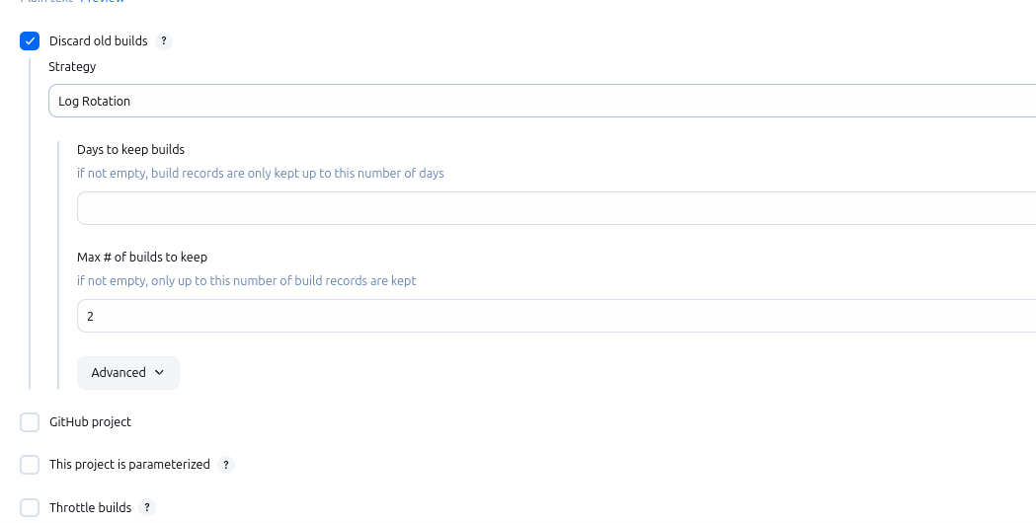

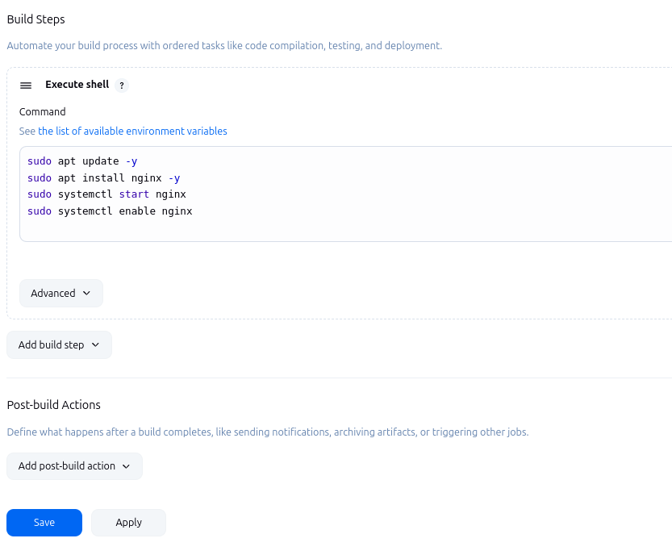

In the terminal give access to all the sections to the jenkins:
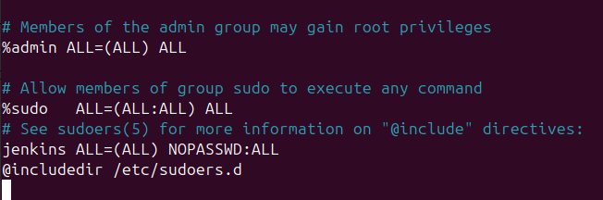

Build in the jenkins(http://localhost:8080)
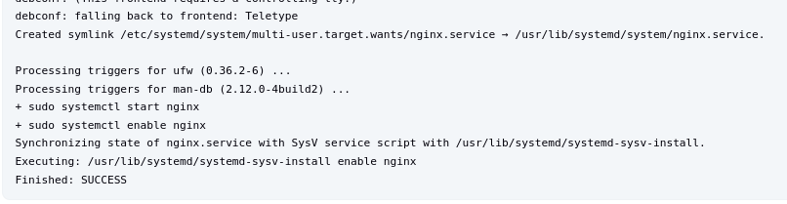

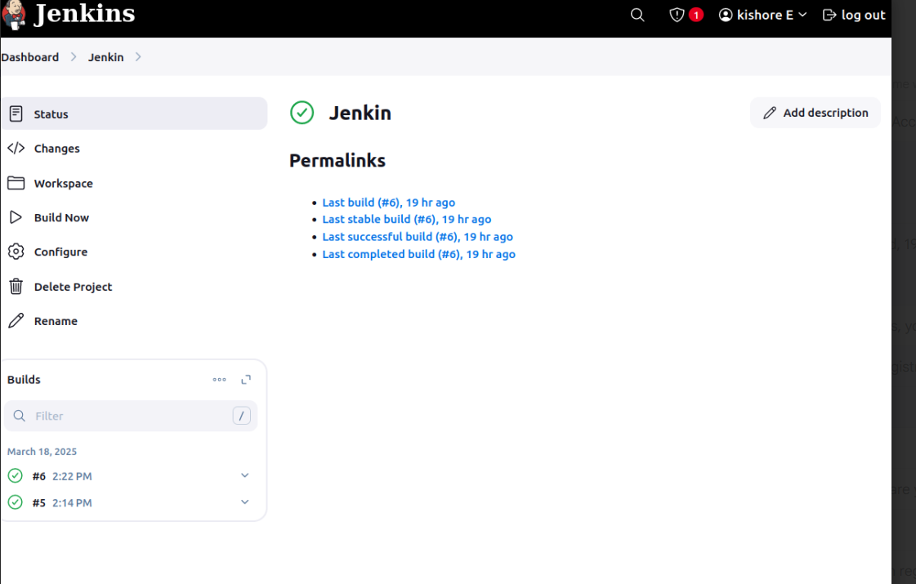

You can see the website in localhost:
